Module 1 // Core Investigation Skills
Threat Hunt: Capture-the-Flag Edition

Help Desk Ticket #4451
Received: 22 April 2026, 09:14 UTC
Reporter: Mark Smith, Finance
Affected machine: NPT-WS01
“My machine was throwing login prompts at me through the night. I ignored it and went back to sleep. Seems fine this morning. Can someone take a look?”
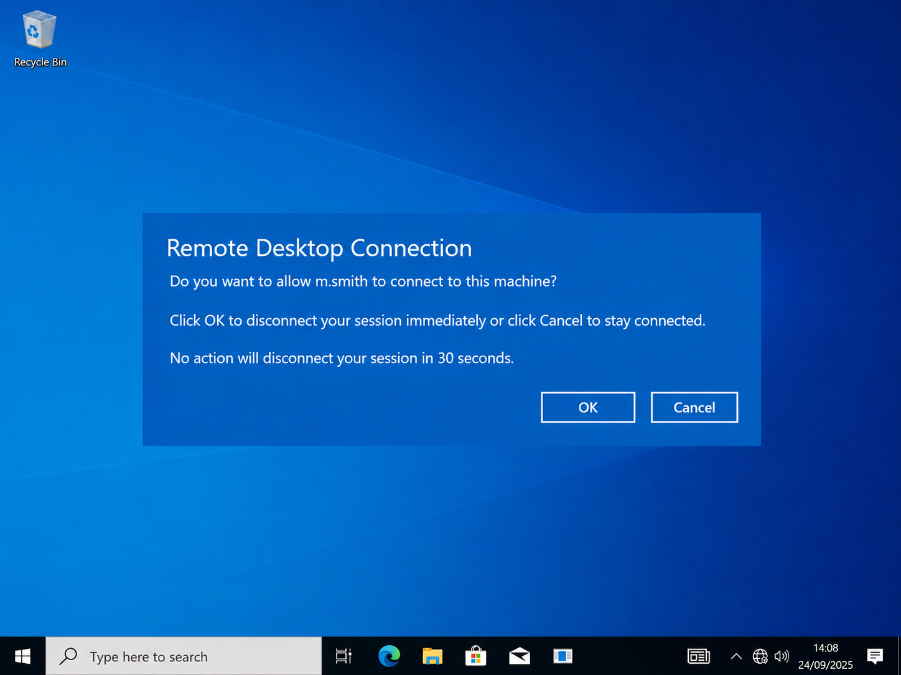
Your mission: Investigate. Decide if this was nothing or something real. If it is real, reconstruct what happened, what got touched, and where the attacker ended up. Along the way you will capture 11 flags. Finish with an investigation report and a containment plan.
Starting point: Microsoft Defender portal (security.microsoft.com), Advanced Hunting.
Focus window: 22 April 2026, 04:30 to 06:00 UTC.
Target host: npt-ws01

How to capture a flag
Each flag is a single real value pulled straight from your hunt results — the exact text shown in one result cell. Run the hunt, find the right row, and copy the cell verbatim. Do not paraphrase, reformat, or summarise it; the value as it appears in the cell is the flag.
Every flag tells you which table and which column the answer lives in. Copy from that cell.

Set this once at the top of every query
let start_time = datetime(2026-04-22T02:00:00.00Z);
let end_time = datetime(2026-04-22T08:00:00.00Z);
let HostInQuestion = "npt-ws01";

The Flags

Flag 1 — The Logon
Skill: Authentication events; recognising a suspicious logon.
Objective: Mark was getting login prompts all night. Find the account the attacker actually succeeded with and then operated under — hint: it’s not Mark's own account.
Capture: the value shown in DeviceLogonEvents → AccountName
Flag: helpdesk
Hint 1 — Nudge: Filter to LogonSuccess in the window, then look at which accounts logged on over the network (LogonType 3). One of them has no business being there.
Hint 2 (table) and Hint 3 (query): ask your instructor.
Answer: helpdeska
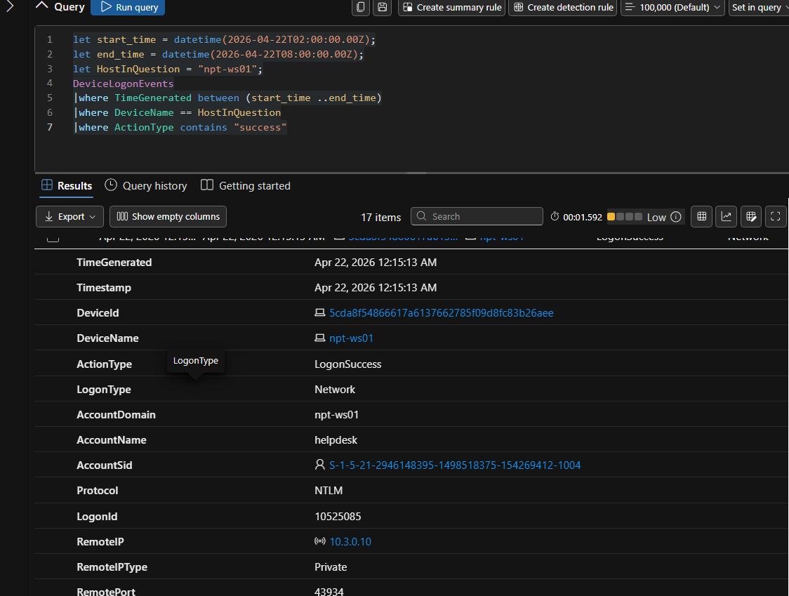

Flag 2 — The Source
Skill: Tying a logon to an external source address.
Objective: Find the external IP address the attacker authenticated from.
Capture: the value shown in DeviceLogonEvents → RemoteIP
Flag:20.110.92.50
Hint 1 — Nudge: Same query as Flag 1 — read across to the RemoteIP column for the suspicious account. An external public IP logging on interactively is the tell.
Hint 2 (table) and Hint 3 (query): ask your instructor.
Answer: 20.110.92.50
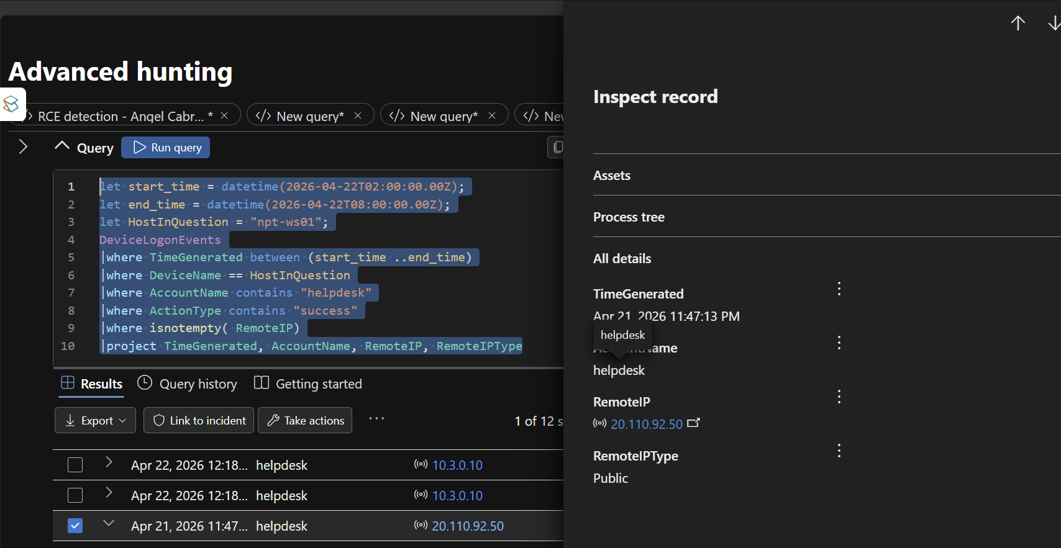

Flag 3 — The Process
Skill: Process execution and command-line analysis.
Objective: Find the command line that launched the implant. It carries a recognisable remote-execution signature.
Capture: the value shown in DeviceProcessEvents → ProcessCommandLine
Flag: cmd.exe /Q /c start "" "C:\Windows\Temp\WindowsUpdate.exe" 1> \Windows\Temp\uYgvso 2>&1
Hint 1 — Nudge: List everything that ran under the helpdesk account. One cmd.exe line silently launches a binary out of a Temp folder — that quiet /Q /c start pattern is the classic Impacket wmiexec fingerprint.
Hint 2 (table) and Hint 3 (query): ask your instructor.
Answer: cmd.exe /Q /c start "" "C:\Windows\Temp\WindowsUpdate.exe"
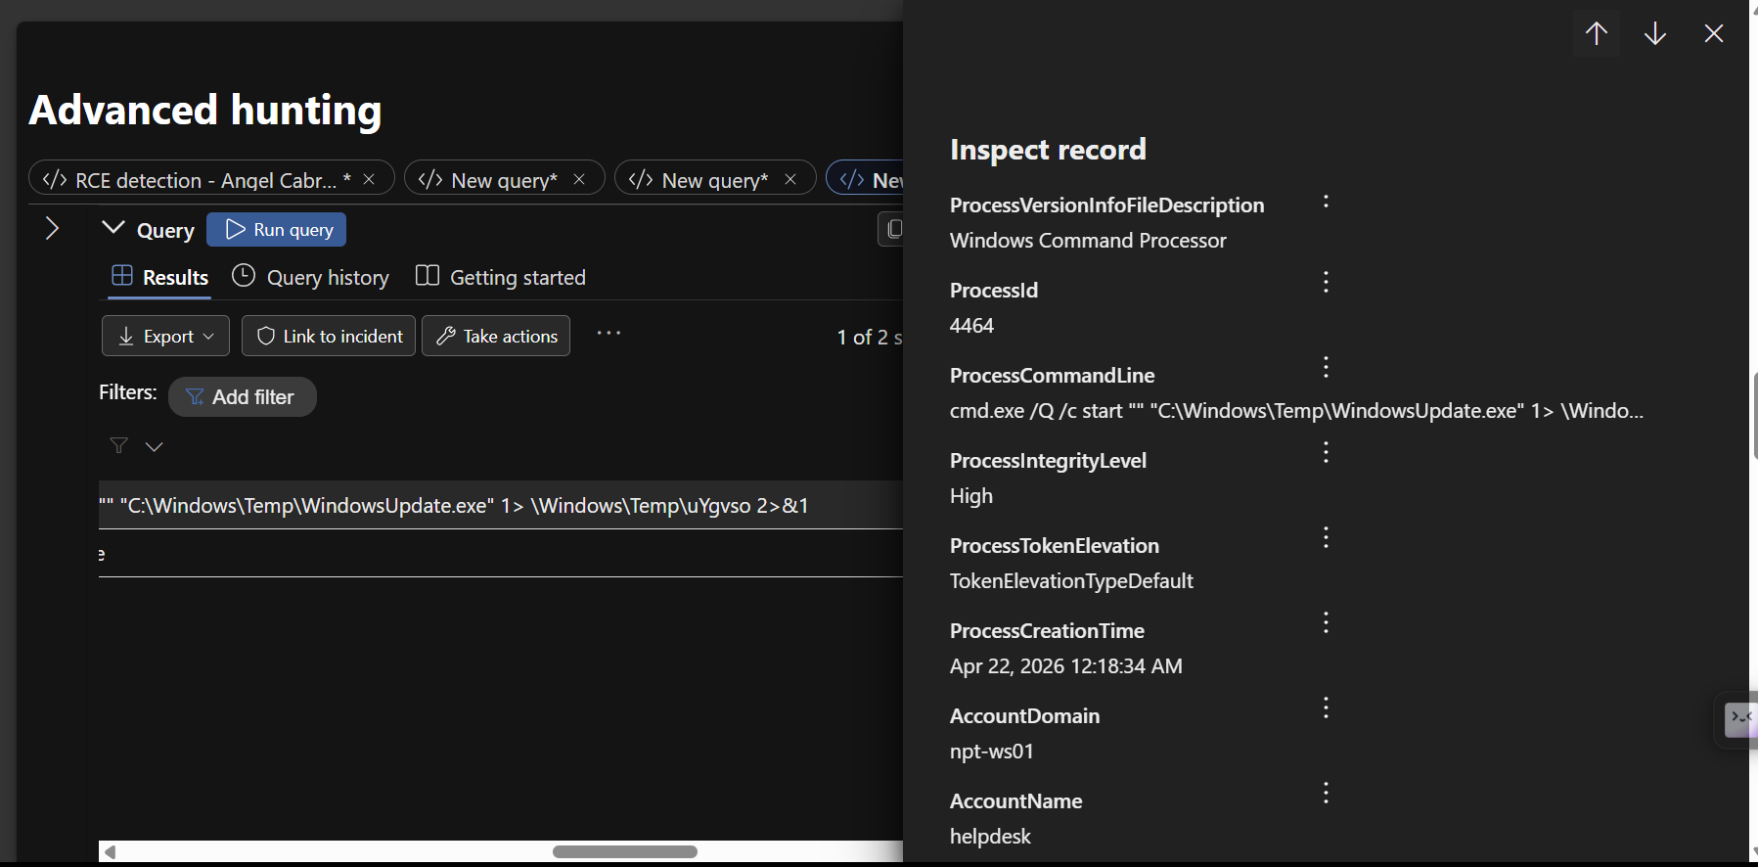

Flag 4 — The Tree
Skill: Parent-child process relationships; reconstructing the chain.
Objective: Identify the immediate parent process that spawned that cmd.exe. This is what confirms remote WMI execution rather than a local user.
Capture: the value shown in DeviceProcessEvents → InitiatingProcessFileName
Flag: wmiprvse.exe
Hint 1 — Nudge: Pivot on the cmd.exe from Flag 3 and look at what spawned it. If the parent is the WMI provider host, you are looking at wmiexec. Trace it up one more level too.
Hint 2 (table) and Hint 3 (query): ask your instructor.
Answer: wmiprvse.exe
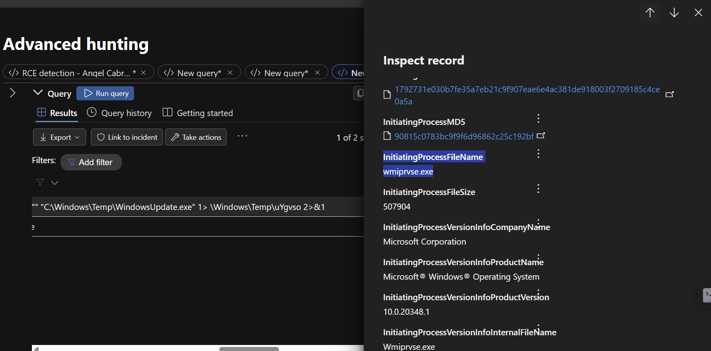

Flag 5 — The Connection
Skill: Outbound C2 (command & control); filtering legitimate Microsoft traffic; resolving the domain IOC.
Objective: Find the command-and-control domain the host beaconed to. (This folds the old Connection and DNS stages into one — the network event and the DNS lookup resolve to the same artifact.)
Capture: the value shown in DeviceNetworkEvents → RemoteUrl
Flag: updates.abordasync.website
Hint 1 — Nudge: Look at outbound 443 from processes that are not Microsoft signed-system binaries, then strip out *.microsoft.com / *.windows.com / *.azure.com. One domain is the odd one out, and it resolves to the IP from Flag 2.
Hint 2 (table) and Hint 3 (query): ask your instructor.
Answer: updates.abordasync.website
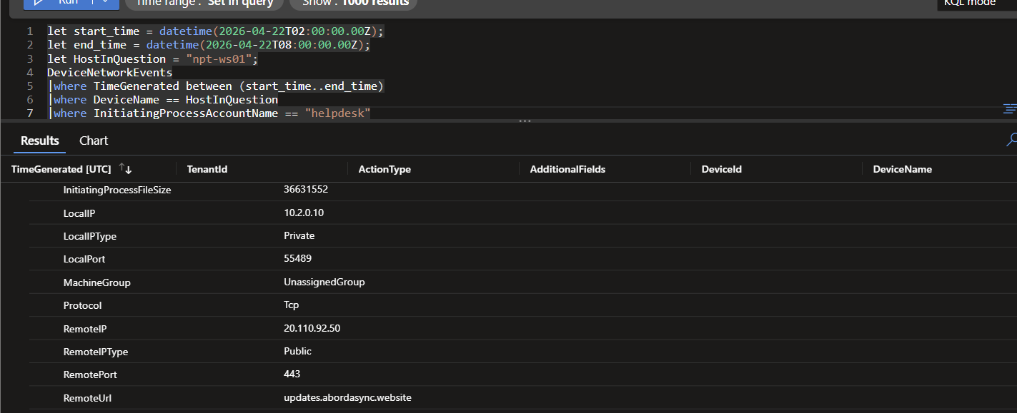

Flag 6 — The File
Skill: File drops in staging locations; network-delivered file attribution.
Objective: Find the SHA256 (hash) of the dropped implant. Capture the full 64-character hash exactly as shown.
Capture: the value shown in DeviceFileEvents → SHA256
Flag: 20cef6a013953890f9d38605d25d60dd63b42b09946bbb18ddb4a456da306e77
Hint 1 — Nudge: Look for an .exe created in a Temp/AppData/Downloads/Public folder in the window. The implant lands in C:\Windows\Temp\. Note the odd creating process — it teaches you something about how it arrived.
Hint 2 (table) and Hint 3 (query): ask your instructor.
Answer: 20cef6a013953890f9d38605d25d60dd63b42b09946bbb18ddb4a456da306e77
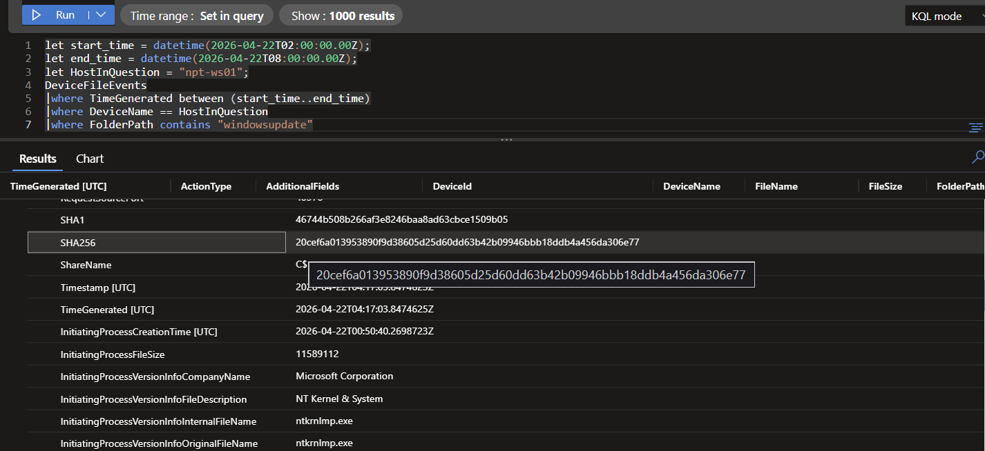

Flag 7 — The Key
Skill: Registry Run-key persistence.
Objective: Find the name of the Run-key value the attacker created for autostart persistence.
Capture: the value shown in DeviceRegistryEvents → RegistryValueName
Flag: WindowsHealthCheck
Hint 1 — Nudge: Look at writes under ...\CurrentVersion\Run. The value name is disguised to look like a legitimate health/update task; its data points back at the implant in Temp.
Hint 2 (table) and Hint 3 (query): ask your instructor.
Answer: WindowsHealthCheck
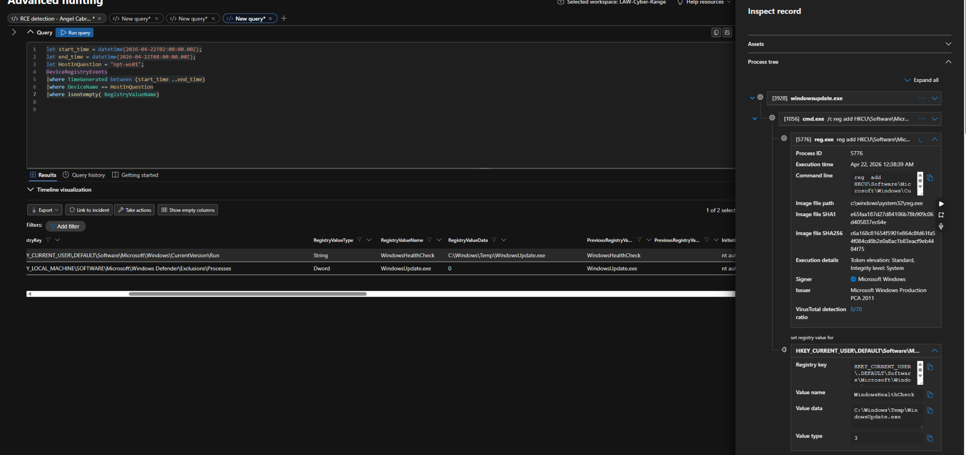

Flag 8 — The Task
Skill: Scheduled-task persistence.
Objective: Find the name of the scheduled task created for persistence.
Capture: the value shown in DeviceProcessEvents → ProcessCommandLine (the /tn value)
Flag: GoogleupdaterTask
Hint 1 — Nudge: Find the schtasks.exe /create command. Read the /tn argument — the task name impersonates a well-known software updater.
Hint 2 (table) and Hint 3 (query): ask your instructor.
Answer: GoogleUpdaterTask
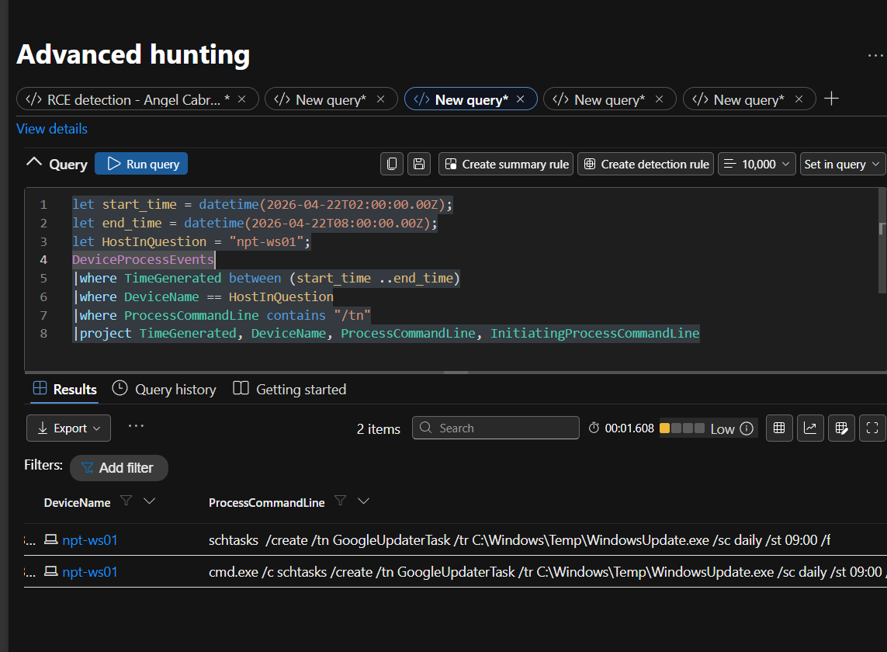

Flag 9 — The Service
Skill: Service-based persistence.
Objective: Find the name of the Windows service the attacker installed to run the implant.
Capture: the value shown in DeviceProcessEvents → ProcessCommandLine (sc.exe create)
Flag: GoogleUpdaterTask
Hint 1 — Nudge: Find the sc.exe create command. The service name and display name both masquerade as a Windows health service; the binPath points at the implant.
Hint 2 (table) and Hint 3 (query): ask your instructor.
Answer: WindowsHealthSvc
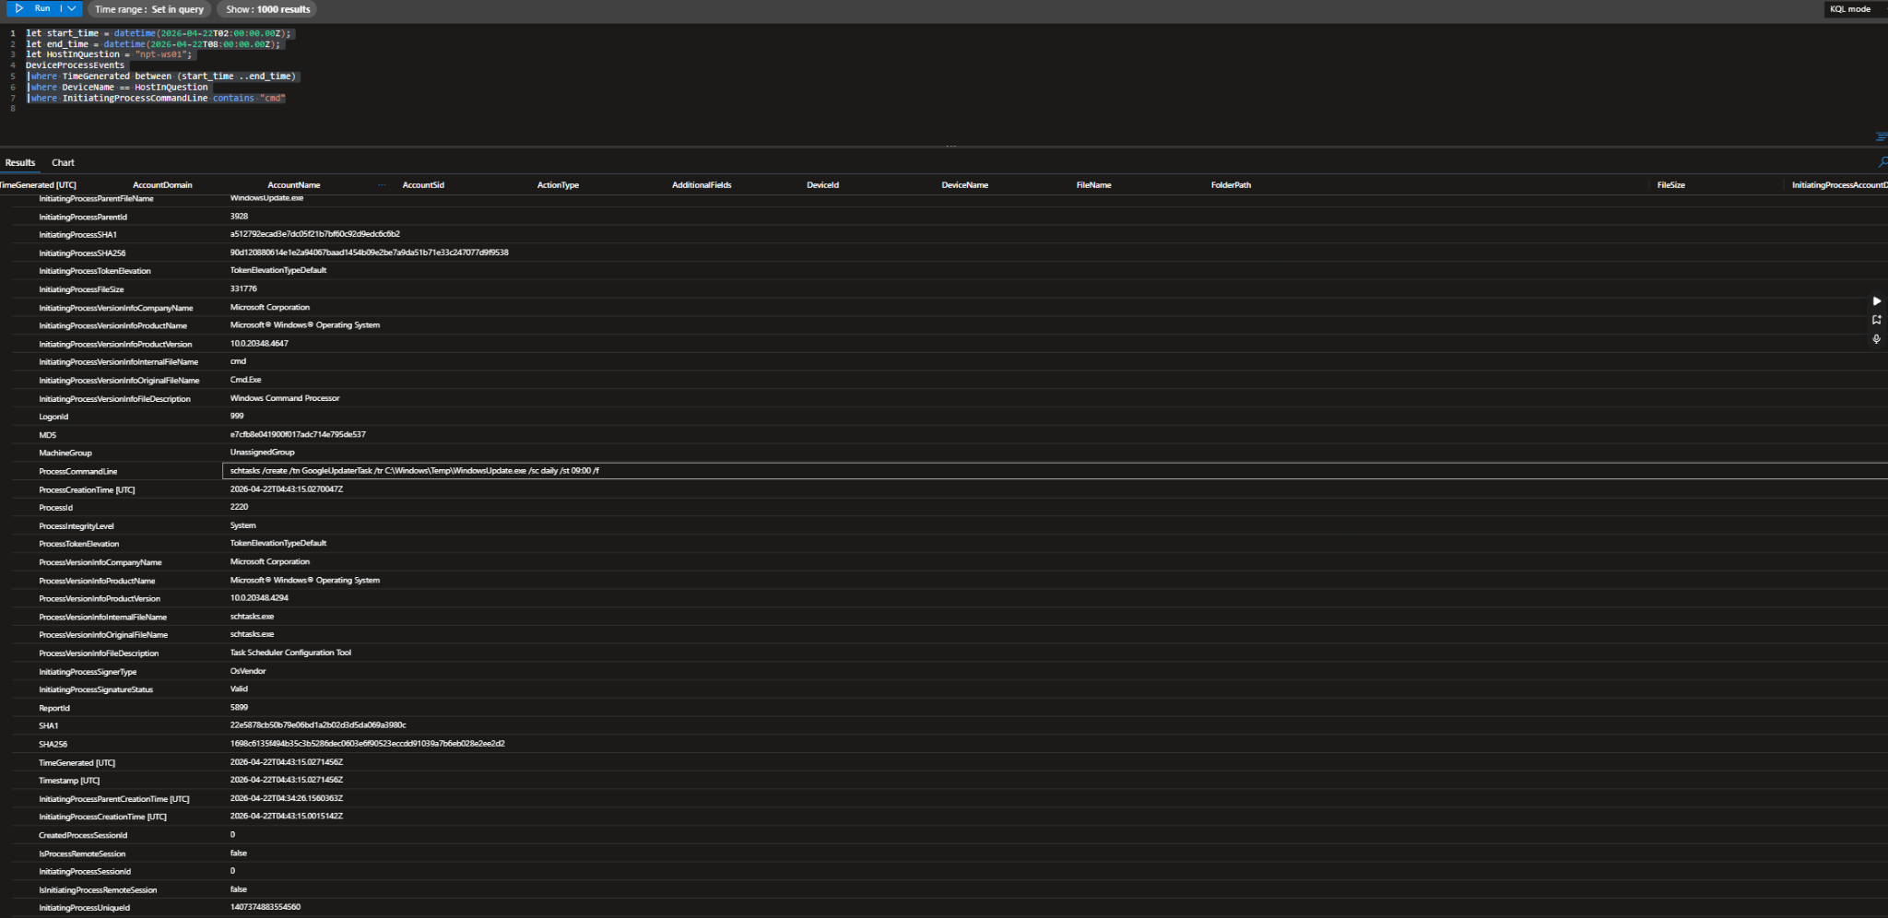

Flag 10 — The Account
Skill: Local account creation and privilege escalation.
Objective: Find the backdoor local user account the attacker created and then promoted to Administrators.
Capture: the value shown in DeviceProcessEvents → ProcessCommandLine (net user ... /add)
Flag: nexus_admin
Hint 1 — Nudge: Look for net.exe / net1.exe with user or localgroup. You should see two correlated events seconds apart: create the account, then add it to Administrators. The flag is the new account name.
Hint 2 (table) and Hint 3 (query): ask your instructor.
Answer: nexus_admin
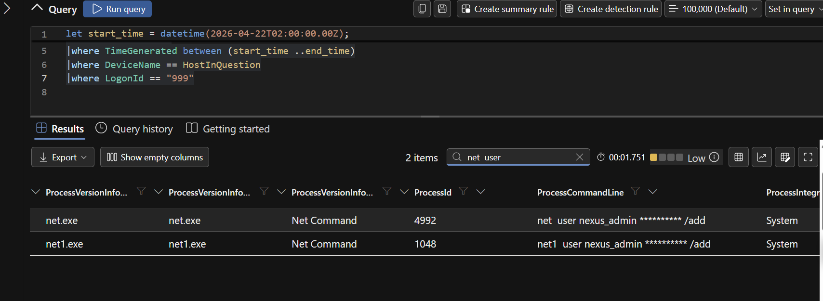

Flag 11 — The Endpoint
Skill: Scoping an investigation across multiple hosts.
Objective: The attacker did not stay on one box. Find the second host they moved toward, so containment can be extended to it.
Capture: the value shown in AlertEvidence / DeviceInfo → DeviceName
Flag: npt-srv01
Hint 1 — Nudge: Look at which devices raised alerts in the window, and check onboarding status across the npt- fleet. The primary is npt-ws01; one other host shows lateral-movement activity.
Hint 2 (table) and Hint 3 (query): ask your instructor.
Answer:
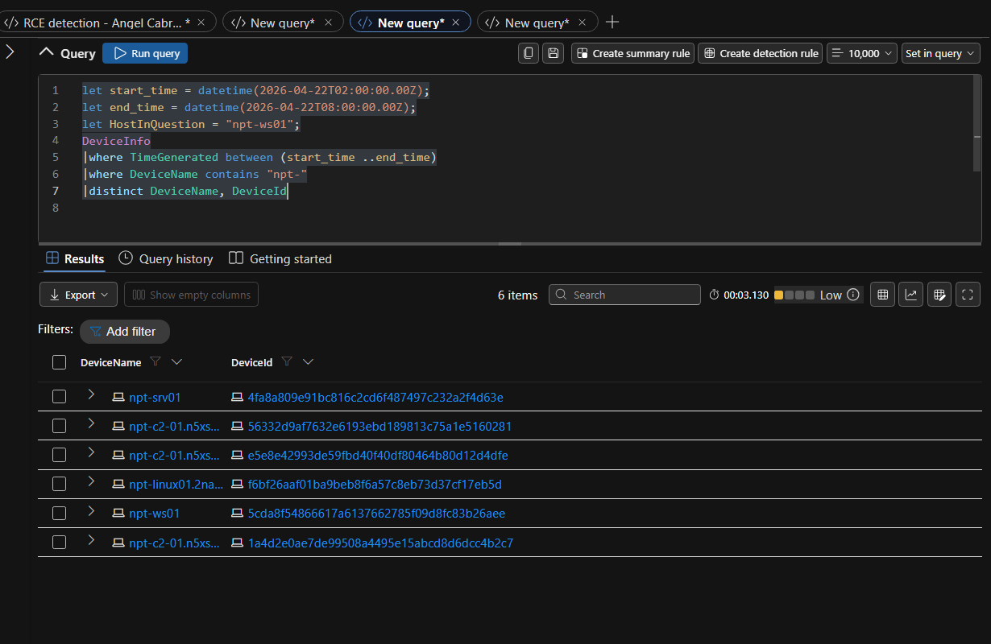
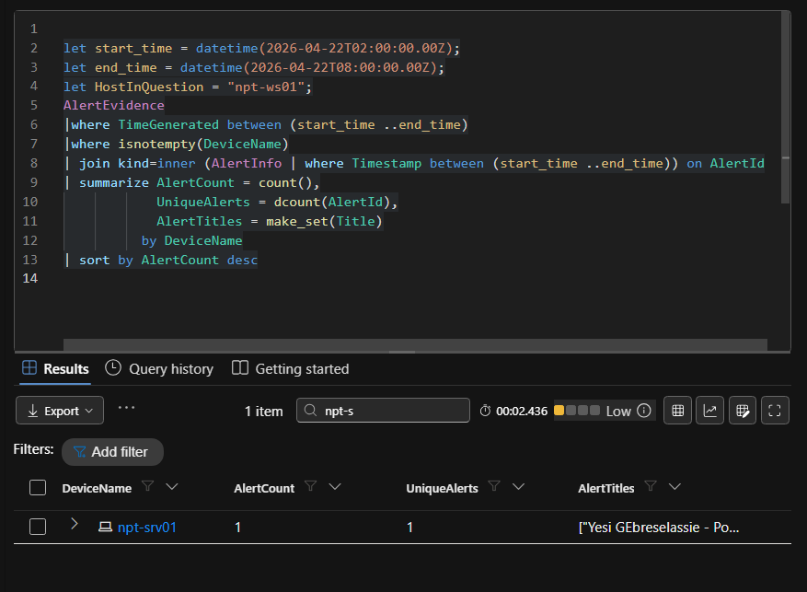npt-srv01dd

Final Deliverables (not flags — you write these)

D1 — Containment plan
Using your captured flags, propose how you would contain and remediate this incident: isolation, accounts to disable, IOCs to block, and every persistence mechanism to remove. Be specific — name the artifacts.

Starting the incident response I would isolate both device NPT WS01 and SRV01 as WS was the first device used for malicious reason and SRV was used as lateral movement. Isolating would stop any other mischievous actions almost immediately following the next step should be to disable the helpdesk account if the company had access to it and the account that was created (nexus_admin).Right next to that would be to get rid of all persistent tasks that were created i.e WindowsHealthcheck and the scheduled task (GoogleUpdaterTask). Next step would be to start blocking the rest of the IOCs. Blocking the IP address 20.110.92.50 and the domain updates.abordasync.website would be the first step. On defender for endpoint we could add the SHA 256 hash 20cef6a013953890f9d38605d25d60dd63b42b09946bbb18ddb4a456da306e77 onto the blocklist. These last steps of deleting things like the file and its hash would be last because in a real world environment we would go through the entire system and devices to find similar or the same instances in those specific nodes.

D2 — Investigation report
Write up the incident as a short investigation report (what happened, the timeline you reconstructed, impact, scope). Defend why you chose that detection point.
Timeline
—
- The attacker was able to login into the NPT WS01 device via the helpdesk account
- Wmiprvse.exe parent commandline process spawns in cmd.exe /Q /c start "" "C:\Windows\Temp\WindowsUpdate.exe"
- stored as Windows\Temp\WindowsUpdate.exe the hash 20cef6a013953890f9d38605d25d60dd63b42b09946bbb18ddb4a456da306e77
- Shortly after there is a connection to the domain updates.abordasync.website
- After the C2 connection is established there are persistent items that are left on the device them being the real looking WindowsHealthCheck and GoogleUpdaterTask
- The attacker then proceeds to create a user called nexus_admin
- Lastly the device laterally moves to NPT-SRV01

Impact
–
- There was remote code execution that happened
- The creation of persistent services and a account user
- C2 connection was established and ongoing
- Evidence of lateral movement was left which means more activity elsewhere

Scope
–
- The compromise of NPT-WS01 which was initial access and C2 connection initiation
- The created account nexus admin
- NPT-SRV01

